Name: _____________________________________________ Period: ________ Date: ____________

**Standard Form**

Standard Form

Ex 1: Write in standard form using integers $y=\frac{3}{4}x+2$

Ex 2: Write in standard form using integers $y=-\frac{2}{5}x+1$

Ex 3: A line with a slope of 1/2 passes through (-4,-1). Write the equation of the line in standard form.

Ex 4: A line with a slope of $\frac{1}{4}$ passes through (-2, 4). Write the equation of the line in standard form.

Ex 5: Write an equation of the line, in standard form, that passes through the points (−6, 1) and (3, −2)?

Ex 6: A line passes through (9, 5) and (12, -7). Write the equation of the line in standard form.

Ex 7:

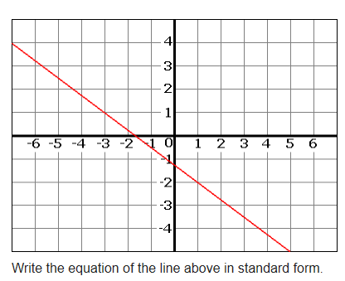

Name: _____________________________________________ Period: ________ Date: ____________

**X- and Y- Intercepts**

X- and Y- Intercepts

* To find the x-intercept ____________________________________________________________

______________________________________________________________________________

* To find the y-intercept ____________________________________________________________

______________________________________________________________________________

Ex 1: What are the x- and y- intercepts of 3x + 4y = 24? Graph using the intercepts.

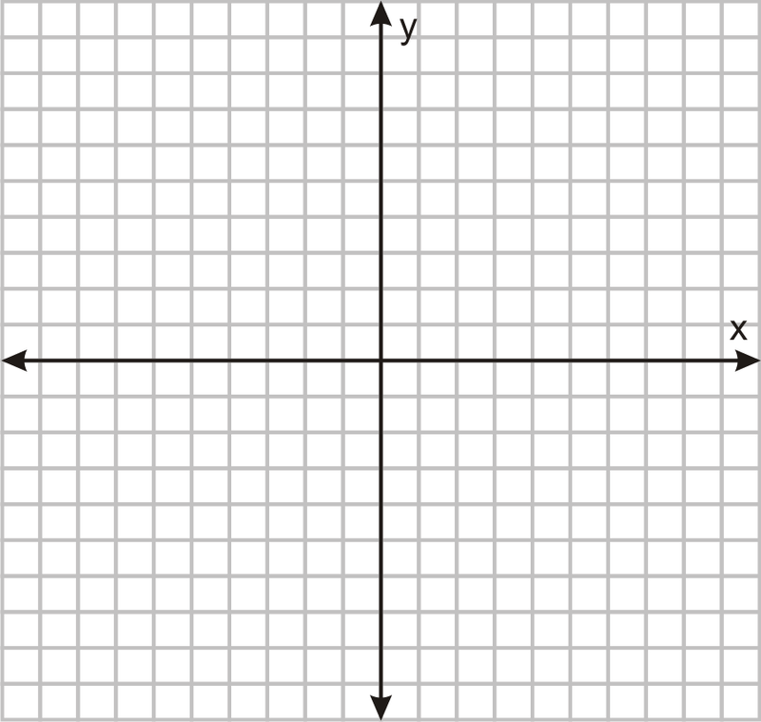

Ex 2: What are the x- and y- intercepts of 5x – 6y = 60? Graph using the intercepts.



Ex 3: What are the x- and y- intercepts of 3x + 8y =12? Graph using the intercepts.



Ex 4: x- and y- intercepts from a graph Ex 5: x- and y- intercepts from a graph

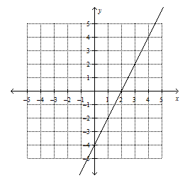 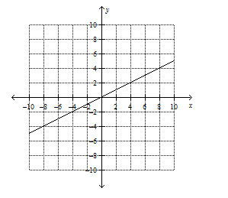

Ex 6: x- and y- intercepts from a graph

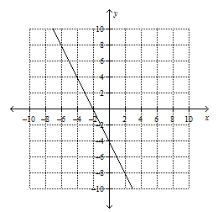

Ex 7: Mrs. Zullo buys a pack of ground coffee. She uses the same amount of ground coffee for each cup she brews. The equation below describes the relationship between the number of cups brewed (x) and ounces of coffee (y) remaining in the pack.

$$x+5y=60$$

How much ground coffee, in ounces, was in the full pack?

Name: _____________________________________________ Period: ________ Date: ____________

**Interpreting Linear Equations**

Ex 1: Matt eats pizza at an average rate of 2 pieces in 7 minutes. At this rate, how many pieces can Matt eat in 42 minutes?

Ex 2: Which statement describes the rate of change of the following function?

f(x) = 4*x* + 5

**A.** The function has a constant rate of change, increasing for all *x* at a rate of 5.

**B.** The function has a varying rate of change when *x* > 5.

**C.** The function has a varying rate of change when *x* > 4.

**D.** The function has a constant rate of change, increasing for all *x* at a rate of 4.

Ex 3: Ava is unpacking boxes of magazines at a bookstore. To track her progress, she records the number of boxes she has left to unpack (y) and the number of hours she has spent unpacking (x).

|  |  |
| --- | --- |
| **Hours Unpacking (x)** | **Boxes Left (y)** |
| 1 | 55 |
| 2 | 51 |
| 3 | 47 |
| 4 | 43 |

If Ava started with 59 boxes and continues to unpack boxes at the same rate, how many more hours will it take her to reach her goal of 19 boxes left to unpack?

Ex 4: A frozen yogurt stand charges per ounce of frozen yogurt purchased. There is an extra charge for a waffle bowl. The total cost (*c*), in dollars, for *f* ounces of frozen yogurt in a waffle bowl, is described by the function *c* = 0.65*f* + 2.

Which statement is true?

* **A.** The cost of 0.65 ounce of frozen yogurt in a waffle bowl is $2.
* **B.** The cost of 0.65 ounce of frozen yogurt in a waffle bowl is $2.65.
* **C.** Each ounce of frozen yogurt costs $0.65 and a waffle bowl is $2 extra.
* **D.** Each ounce of frozen yogurt costs $2 and a waffle bowl is $0.65 extra.

Ex 5: The total cost of a plane ride, *C*, is given below as a function of the time flown, *m*, in minutes.

* *C* = $45.00 + $1.50*m*

If a customer spends $225.00 on a plane ride, how many minutes does the ride last?

Ex 6: Alexis bought *x* gallons of gas at a price of $3.04 per gallon at his local gas station. When he paid for the gas, Alexis also paid $15.80 for snacks and drinks.

If Alexis filled 15 gallons of gas, how much did he spend in all at the gas station?

Ex 7: Mrs. Walck leaves the check-in counter at the airport and walks to a moving sidewalk, which takes her to her gate. Mrs. Walck’s distance (d), in meters, from the check-in counter while she has been standing on the moving sidewalk for s seconds, is described by the function



$d=3s+15$

Which statement is true?

* A. Mrs. Walck is 3 meters from the check-in counter after 18 seconds
* B. Mrs. Walck is 15 meters from the check-in counter after 21 seconds.
* C. Mrs. Walck moves 3 meters per second while standing on the moving sidewalk, and she has walked 15 meters to get to the moving sidewalk.
* D. Mrs. Walck moves 15 meters per second while standing on the moving sidewalk, and she has walked 3 meters to get to the moving sidewalk.